The Power of Habit: Why We Do What We Do in Life and in Business

One day in the early 1900s, a prominent American executive named Claude C. Hopkins was approached by an old friend with a new business idea. The friend had discovered an amazing product, he explained, that he was convinced would be a hit. It was a toothpaste, a minty, frothy concoction he called "Pepsodent."

Claude Hopkins was best known for a series of rules he coined explaining how to create new habits among consumers. These rules would transform industries and eventually became conventional wisdom among marketers, educational reformers, public health professionals, politicians, and CEOs. Even today, Hopkins's rules influence everything from how we buy cleaning supplies to the tools governments use for eradicating disease. They are fundamental to creating any new routine.

However, when his old friend approached Hopkins about Pepsodent, the ad man expressed only mild interest. It was no secret that the health of Americans' teeth was in steep decline. As the nation had become wealthier, people had started buying larger amounts of sugary processed foods. When the government started drafting men for World War I, so many recruits had rotting teeth that officials said poor dental hygiene was a national security risk.

The problem at the time was that hardly anyone bought toothpaste because, despite the nation’s dental problems, hardly anyone brushed their teeth, so Hopkins gave his friend's proposal a bit of thought, and then declined. The friend, however, was persistent. He came back again and again, appealing to Hopkins's considerable ego until, eventually, the ad man gave in.

It would be the wisest financial decision of Hopkins's life. Within five years of that partnership, Hopkins turned Pepsodent into one of the best-known products on earth and, in the process, helped create a toothbrushing habit that moved across America with startling speed. A decade after the first Pepsodent campaign, pollsters found that toothbrushing had become a ritual for more than half the American population. Hopkins had helped establish toothbrushing as a daily activity. The secret to his success, Hopkins would later boast, was that he had found a certain kind of cue and reward that fueled a particular habit. It's an alchemy so powerful that even today the basic principles are still used by video game designers, food companies, hospitals, and millions of salesmen around the world. Claude Hopkins that showed how new habits can be cultivated and grown.

So what, exactly, did Hopkins do?

He created a craving. And that craving, it turns out, is what makes cues and rewards work. That craving is what powers the habit loop.

To sell Pepsodent, Hopkins needed a trigger that would justify the toothpaste's daily use. He sat down with a pile of dental textbooks. "It was dry reading," he later wrote. "But in the middle of one book I found a reference to the plaque on teeth, which I afterward called 'the film.' That gave me an appealing idea. I resolved to advertise this toothpaste as a creator of beauty. To deal with that cloudy film."

In focusing on tooth film, Hopkins was ignoring the fact that his same film has always covered people's teeth and hadn’t seemed to bother anyone. People had never paid much attention to it, and there was little reason why they should: You can get rid of the film by eating an apple, running your finger over your teeth, brushing, or vigorously swirling liquid around your mouth. Toothpaste didn't do anything to help remove the film.

That didn’t stop Hopkins from exploiting his discovery. Here, he decided, was a cue that could trigger a habit. Soon, cities were plastered with Pepsodent ads.

"Just run your tongue across your teeth," read one. "You’ll feel of film that's what makes your teeth look 'off color' and invites decay." “Pepsodent removes the film!"

The brilliance of these appeals was that they relied upon a cue: tooth film that was universal and impossible to ignore. Telling someone to run their tongue across their teeth, it turned out, was likely to cause them to run their tongue across their teeth. And when they did, they were likely to feel a film. Hopkins had found a cue that was simple, had existed for ages, and was so easy to trigger that an advertisement could cause people to comply automatically.

Moreover, the reward, as Hopkins envisioned it, was even more enticing. 'Who, after all, doesn’t want to be more beautiful? Who doesn't want a prettier smile? Particularly when all it takes is a quick brush with Pepsodent?

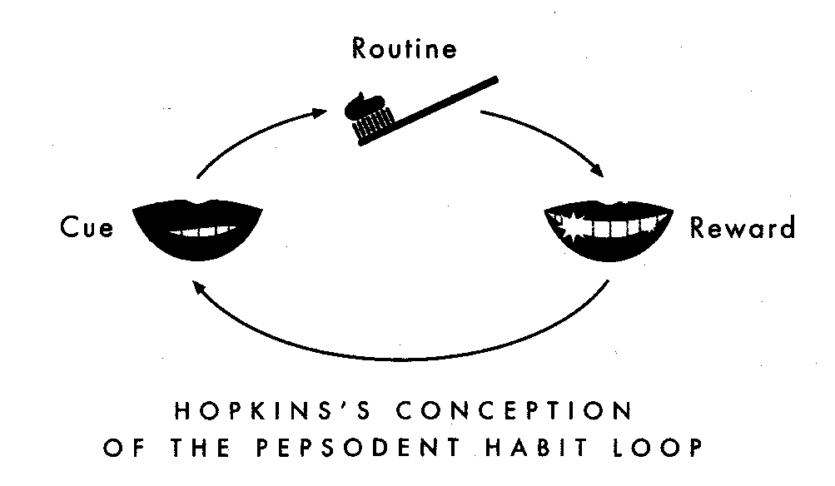

After the campaign launched, a quiet week passed. Then two. In the third week, demand exploded. There were so many orders for Pepsodent that the company couldn’t keep up. Within a decade, Pepsodent was one of the top selling goods in the world and remained America's bestselling toothpaste for more than thirty years.

Before Pepsodent appeared, only 7 percent of Americans had a tube of toothpaste in their medicine chests. A decade after Hopkins's ad campaign went nationwide, that number had jumped to 65 percent. By the end of World War II, the military downgraded concerns about recruits' teeth because so many soldiers were brushing every day.

"I made for myself a million dollars on Pepsodent," Hopkins wrote a few years after the product appeared on shelves. The key, he said, was that he had "learned the right human psychology." That psychology was grounded in two basic rules:

First, find a simple and obvious cue.

Second, clearly define the rewards.

If you get those elements right, Hopkins promised, it was like magic. Look at Pepsodent: He had identified a cue tooth film and a reward- beautiful teeth- that had persuaded millions to start a daily ritual. Those same principles have been used to create thousands of other habits. Studies of people who have successfully started new exercise routines, for instance, show they are more likely to stick with a workout plan if they choose a specific cue, such as running as soon as they get home from work, and a clear reward, such as an evening of guilt-free television. Research on dieting says creating new food habits requires a predetermined cue such as planning menus in advance and simple rewards for dieters when they stick to their intentions.

However, it turns out that Hopkins's two rules aren’t enough. There's also a third rule that must be satisfied to create a habit, a rule so subtle that Hopkins himself relied on it without knowing it existed. It explains everything from why it's so hard to ignore a box of doughnut to how a morning jog can become a nearly effortless habit…

Hopkins's experiences with Pepsodent weren't quite as straightforward as he portrays them in his memoirs. Though he boasted that he discovered an amazing cue in tooth film and bragged that the was the first to offer consumers the clear reward of beautiful teeth, it turns out that Hopkins wasn’t the originator of those tactics. Not by a long shot. Consider, for instance, some of the advertisements for other toothpastes that filled magazines and newspapers even before Hopkins knew that Pepsodent existed'

"The ingredients of this preparation are especially intended to prevent deposits of tartar from accumulating around the necks of the teeth," read an ad for Dr. Sheffield s Creme Dentifrice that predated Pepsodent. "Clean that dirty layer!"

Dozens of other advertising men had used the same language as Pepsodent years before Hopkins jumped in the game. All of their ads had promised to remove tooth firm and had offered the reward of beautiful, white teeth. None of them had worked. But once Hopkins launched his campaign, sales of Pepsodent exploded. So why was Pepsodent different?

Hopkins's success was driven by the fact that Pepsodent created a craving. Unlike other pastes of the period, Pepsodent contained citric acid, as well as doses of mint oil and other chemicals. Pepsodent's inventor used those ingredients to make the toothpaste taste fresh, but they had another, unanticipated effect as well. They're irritants that create a cool, tingling sensation on the tongue and gums.

After Pepsodent started dominating the marketplace, researchers at competing companies scrambled to figure out why. what they found was that customers said that if they forgot to use Pepsodent, they realized their mistake because they missed that cool, tingling sensation in their mouths. They expected, they craved, that irritation. If it wasn’t there, their mouths didn’t feel clean.

Claude Hopkins wasn't selling beautiful teeth. He was selling a sensation. once people craved that cool tingling once they equated it with cleanliness brushing became a habit.

Adapted from: Duhigg, C. (2014) *The power of habit: Why we do what we do in life and in business*. New York, NY: Random House.